

**Project**

**Electrical Circuits**

**CSE – 209**

**Title: PSpice Analysis for Maximum Power Transfer**

# Submitted by-

Name: D.M. Rafiun Bin Masud (2019-3-60-137)

Section: 5

# Submitted to-

M. Saddam Hossain Khan

## Senior Lecturer

Department of Computer Science & Engineering

East West University

**Submission Date: 13.01.2022**

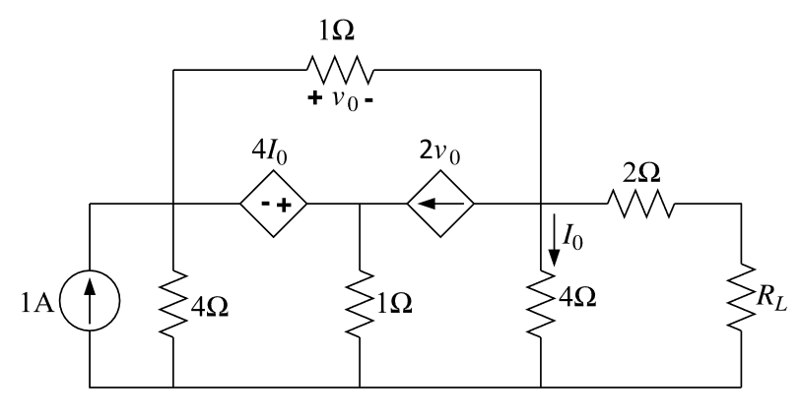

**Figure01: Given circuit**

**Question 1**

**Answer:**

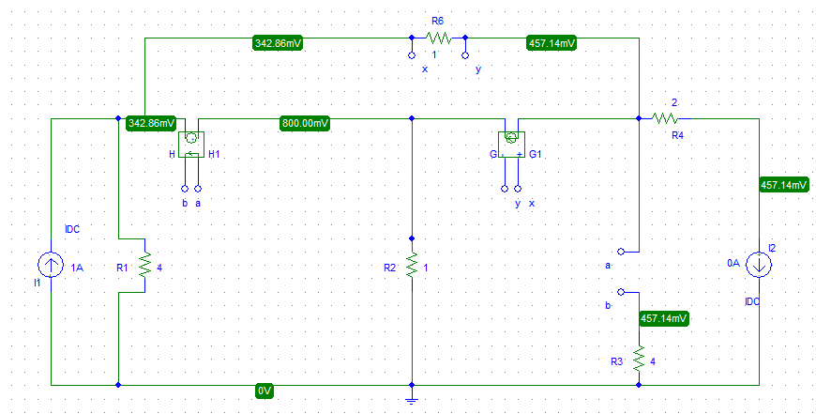

**Figure: 02**

From the figure:02 we find Voc = 0.45714V

Again,

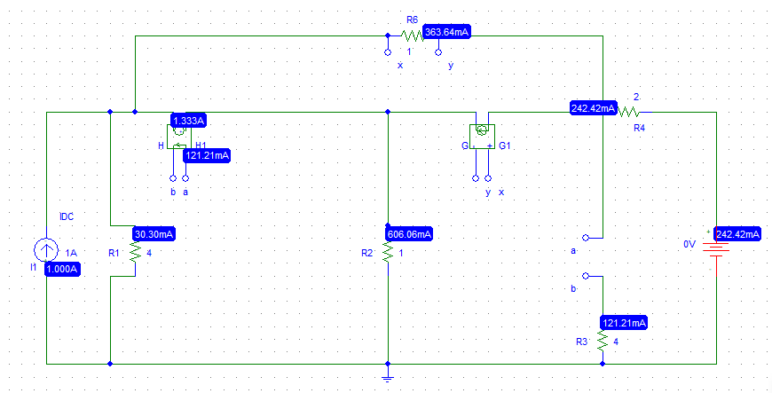

**Figure: 03**

From the figure:03 we find Isc = 0.24242A

It was needed to replace in (Figure: 02) the $R_{L}$ 0A current source in (Figure: 03). Also, replaced $R_{L}$ with 0V voltage source. Now, open circuit voltage ($V_{oc}$) and short circuit current ($I_{sc}$) could be measured respectively.

We know,

$R_{th}$ = $\frac{V_{oc}}{I_{sc}}$

= $\frac{ 0.45714}{0.24242}$

= 1.885 Ω

So, the Thevenin’s equivalent circuit is,

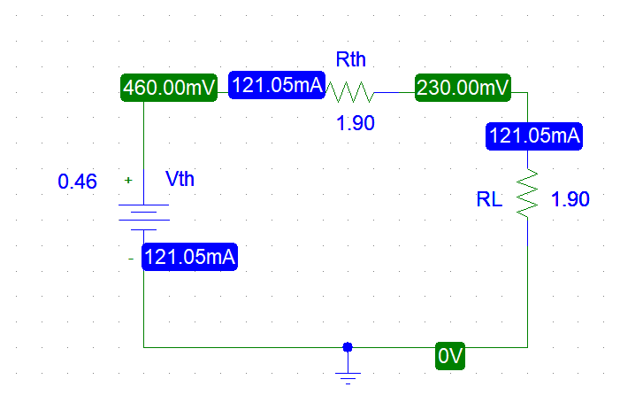

Figure: 04

**Question 2**

**Answer:**

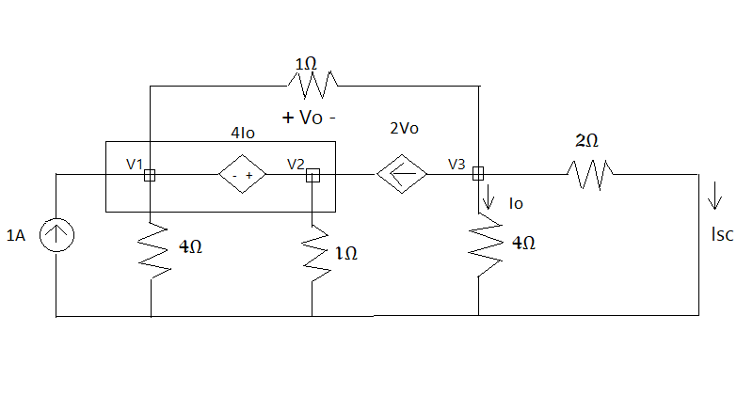

**Figure 05: Voc**

Applying KCL at super node,

-1+(V1/4) +V1-V3+V2-2(V1-V3) =0

or, (-3/4 V1) +V2+V3 =1………………..(1)

Applying KCL at node 3,

V3-V1 +2(V1-V3) + V3 /4 = 0

or, V1 – (3/4 V3 ) = 0 ………………..…(ii)

Voltage difference of super node,

V2 - V1 =4* V3 / 4

or, - V1 + V2 - V3 = 0 …………………(iii)

After calculation from equation (i), (ii), And iii

V3 = 16/35 =0.45714 V

V3 = Voc =Vth= 0.45714 V

Now,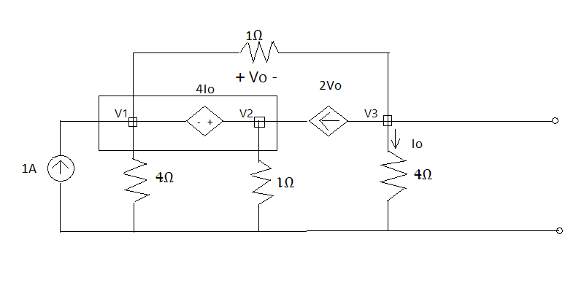

**Figure:06**

Applying KCL at Super Node,

-1+(V1/4) +V1-V3+V2-2(V1-V3) =0

or, -3/4 V1 + V2 + V3 = 1…….(1)

Applying KCL at Super Node 3,

V3 - V1 + 2(V1 - V3) + V3 / 4 + V3 / 2 =0

or V1 – 1/4 V3 = 0…… (2)

Voltage difference of super node,

- V1 + V2 - V3 = 0……(3)

After calculation from equation 1,2 and 3,

We get,

V3 = 0.48484V

So, Isc = $\frac{V3}{2}$

Isc =

Isc = 0.24242A

$R_{L}=R_{th}$ = $\frac{V_{oc}}{I_{sc}}$

$R_{th}$ = $\frac{ 0.45714}{0.24242}$

$R_{th}$ =1.885Ω

$P_{Lmax}$ = $\frac{v_{th^{2}}}{4R_{L}}$

$P_{Lmax}$ = $\frac{{\left(0.45714\right)}^{2}}{4×1.89}$

$P_{Lmax}$ = 0.0276W

Or $P_{Lmax}$ = 0.0278W

So, $P_{Lmax}$ = 0.028W

**Question 3**

**Answer:**

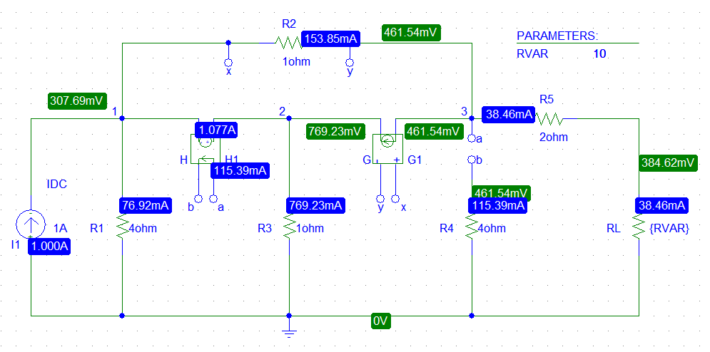

**Figure: 07**

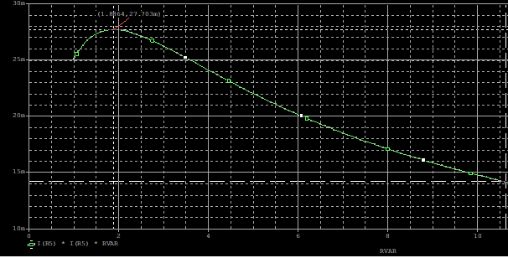

**Figure 08: Simulation graph**

After the simulation using PSpice with resistance sweep, it is determined that the value of maximum power transferred to $R_{L}$ is 1.885Ω. And the corresponding maximum power is 27.705 mW.

**Question 4**

**Answer:**

From the table we can see there is no difference between theoretically calculation and PSpice simulation.

|  |  |  |
| --- | --- | --- |
|  | **STEP 2** | **STEP 3** |
| **RL** | 1.885 Ω | 1.885 Ω |
| **PLmax** | 0.028W | 0.028W |

